- Apply relational algebra operations (σ, π, ∪, -, ×, ⋈) on the give Employee and Department relations to retrieve required records.

Assume:
Employee(EmpID, EmpName, DeptID, Salary)
Department(DeptID, DeptName)
σ DeptID='D1' (Employee)
π EmpName (Employee)
π DeptID(Employee) ∪ π DeptID(Department)
π DeptID(Department) − π DeptID(Employee)
Employee × Department
Employee ⋈ Employee.DeptID = Department.DeptID Department

- Write SQL DDL statements to create STUDENT(SID, Name, DOB,
DeptID) and DEPARTMENT(DeptID, DeptName) tables with all
appropriate constraints.

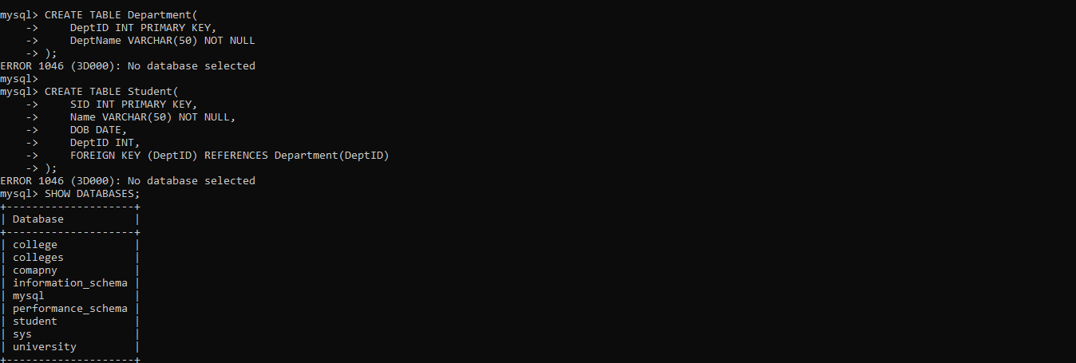
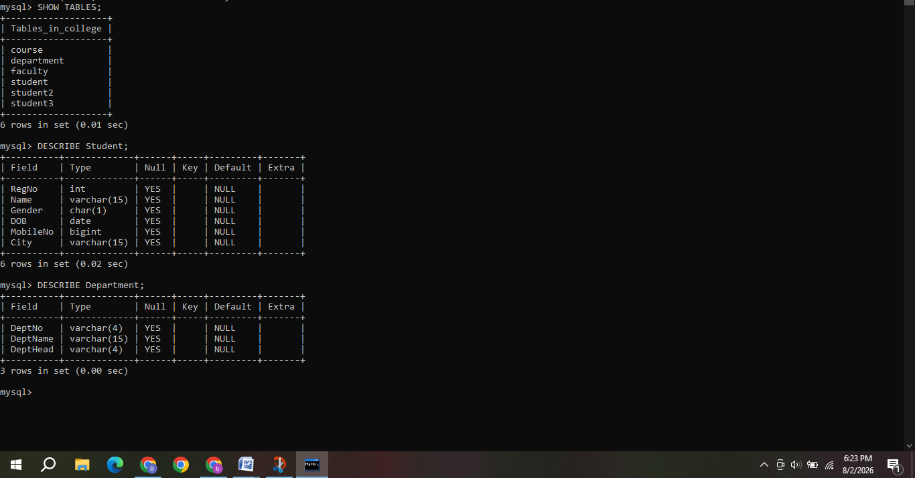
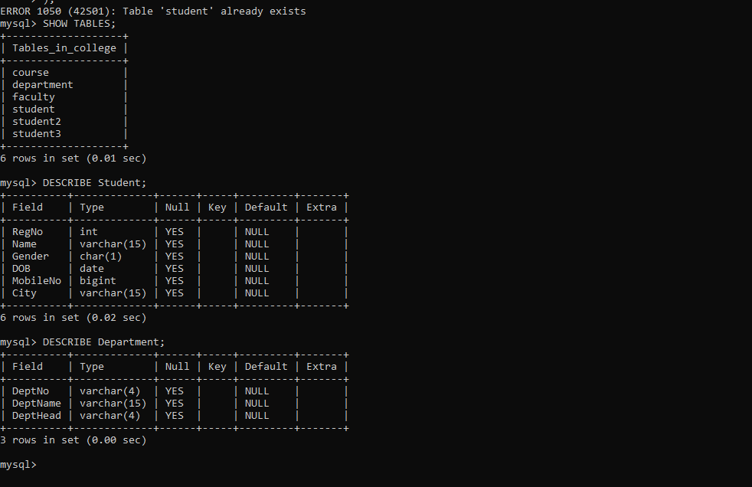

3) Formulate SQL queries using GROUP BY, HAVING, and aggregate
functions (COUNT, SUM, AVG, MAX, MIN) on a given Sales
dataset.
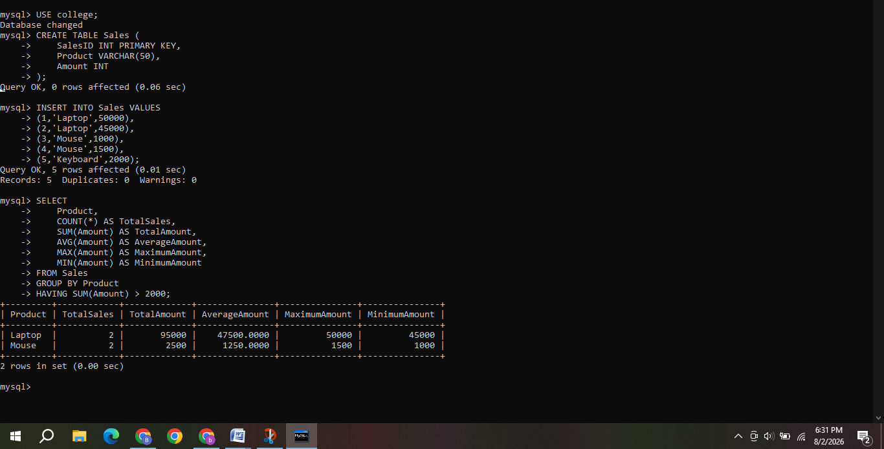
4) Write a correlated sub-query to find employees earning more than the average salary of their own department.\
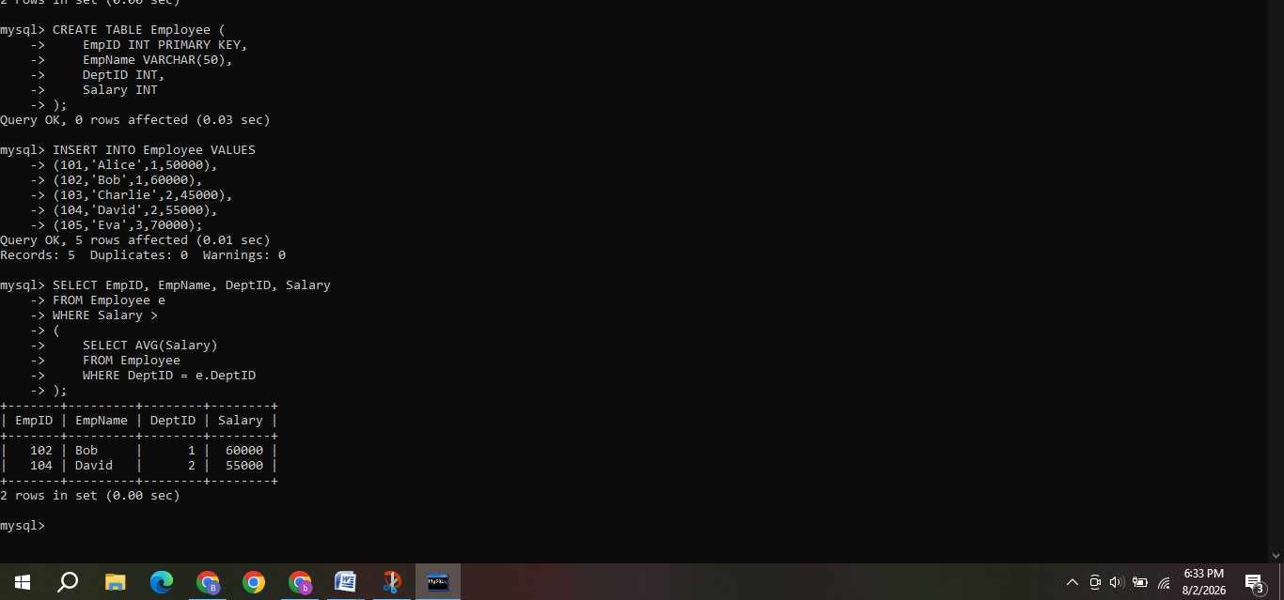
5) Apply all types of JOIN operations (INNER, LEFT OUTER, RIGHT
OUTER, FULL OUTER, CROSS) on Employee and Project tables.
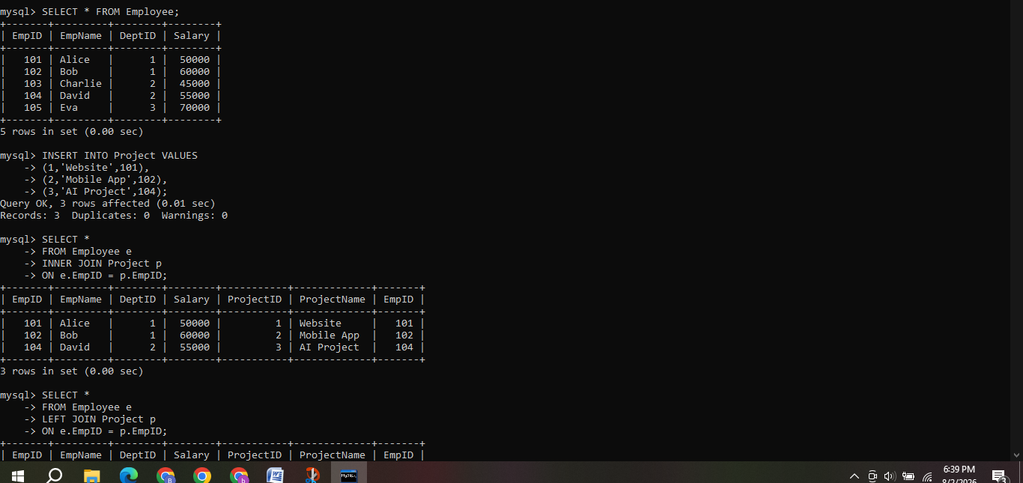
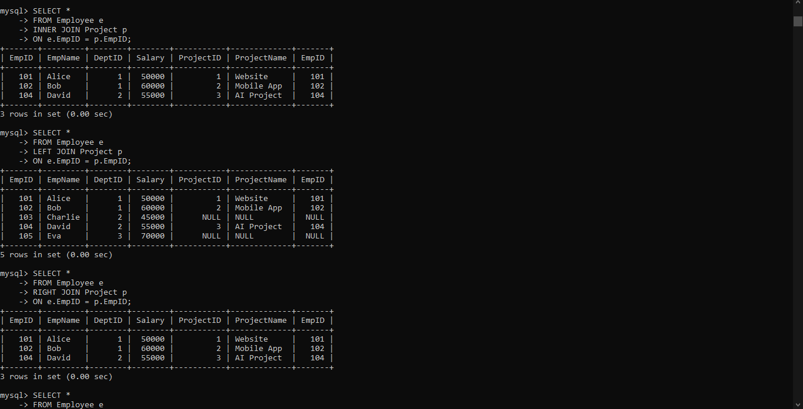
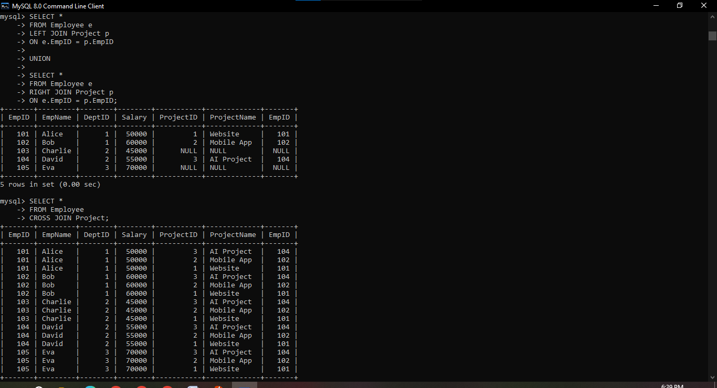
6) Create a view DeptSalaryView that displays department name, total employees, and average salary. Write a query on this view.
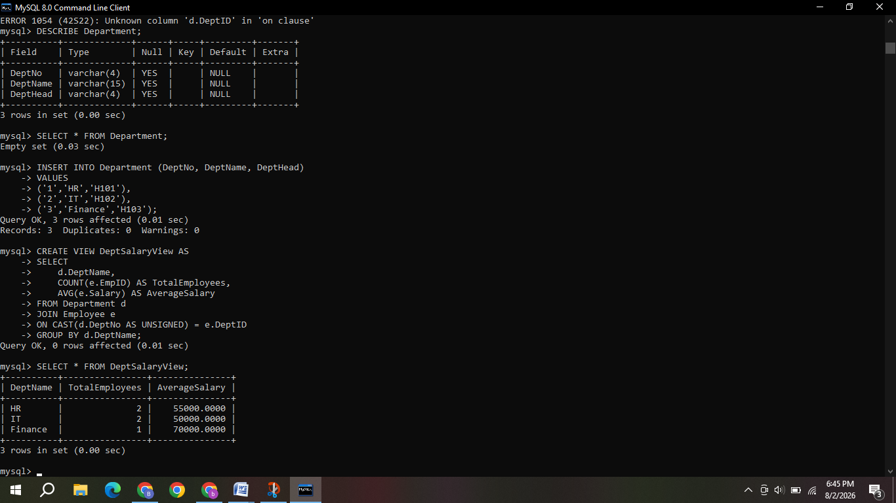

7) Construct a relational algebra expression for the following: Find
names of students who are enrolled in all courses offered.
Assume the relations:
- Student(SID, StudentName)
- Enrollment(SID, CourseID)
- Course(CourseID)
Relational Algebra Expression:
π StudentName ( Student ⋈ ( Enrollment ÷ π CourseID(Course) ) )
Explanation:
1. π CourseID(Course) retrieves all course IDs.
2. Enrollment ÷ π CourseID(Course) finds students enrolled in every course.
3. Student ⋈ (...) joins the result with the Student relation.
4. π StudentName displays only the names of those students.
8) Write SQL DML statements (INSERT, UPDATE, DELETE) with integrity constraint enforcement for a given scenario.
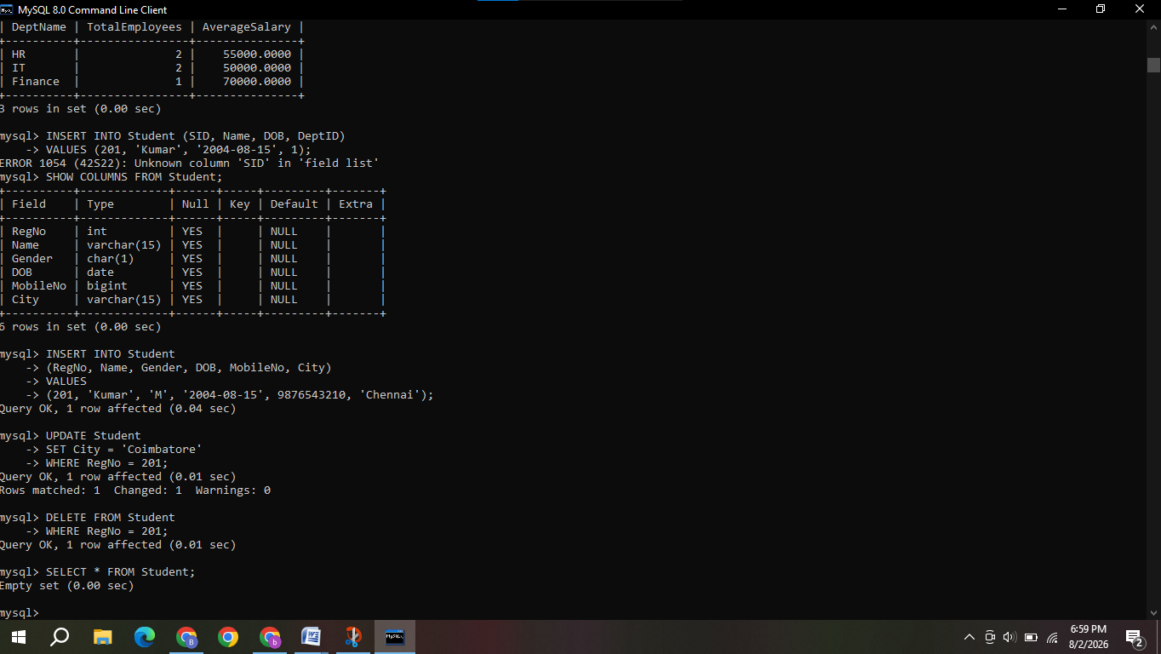
9) Apply tuple relational calculus to express a query: Find all
employees who work in the &#39;IT&#39; department and earn more than
50000.
Assume the relation:
Employee (EmpID, EmpName, DeptID, Salary)
and Department(DeptID, DeptName)
Tuple Relational Calculus Expression:

{ e.EmpName |
Employee(e) ∧
∃ d ( Department(d) ∧
e.DeptID = d.DeptID ∧
d.DeptName = 'IT' ∧
e.Salary > 50000
)
}

Explanation
- Employee(e) selects tuples from the Employee relation.
- Department(d) selects tuples from the Department relation.
- e.DeptID = d.DeptID joins Employee and Department.
- d.DeptName = 'IT' filters employees in the IT department.
- e.Salary > 50000 returns only employees earning more than 50000.
- e.EmpName displays the names of those employees.
10) Design a relational schema for an Airline Reservation System and
write 5 SQL queries demonstrating joins, sub-queries, and views.
